ISO TC 215/SC N
Date: 2006-05-30
ISO/PDTS 21298
ISO TC 215/SC /WG 4
Secretariat: ANSI
Health informatics — Functional and structural roles
Copyright notice
This ISO document is a working draft or committee draft and is copyright-protected by ISO. While the reproduction of working drafts or committee drafts in any form for use by participants in the ISO standards development process is permitted without prior permission from ISO, neither this document nor any extract from it may be reproduced, stored or transmitted in any form for any other purpose without prior written permission from ISO.
Requests for permission to reproduce this document for the purpose of selling it should be addressed as shown below or to ISO's member body in the country of the requester:
[Indicate the full address, telephone number, fax number, telex number, and electronic mail address, as appropriate, of the Copyright Manger of the ISO member body responsible for the secretariat of the TC or SC within the framework of which the working document has been prepared.]
Reproduction for sales purposes may be subject to royalty payments or a licensing agreement.
Violators may be prosecuted.

Contents Page
1 Scope 1
2 Normative references 1
3 Terms and definitions 1
4 Abbreviations 3
5 Role Model 4
5.1 Roles and policy aspects 4
5.2 Roles in privilege management 5
5.3 Structural roles 5
5.3.1 Structural roles of healthcare professions from the International Labour Organization 5
5.3.2 Medical Specialties 7
5.4 Functional roles 11
6 Formally modelling roles 12
6.1 Roles within the Generic Component Model 12
6.2 Developing the role model 12
6.2.1 Assignment of Structural Roles 13
6.2.2 Generic role specification 14
6.3 Relationships between Structural and Functional Roles 14
7 Use cases for the use of structural and functional roles 15
Annex A (informative) ISCO-08 Sample Mapping 16
Annex B 24

Foreword
ISO (the International Organization for Standardization) is a worldwide federation of national standards bodies (ISO member bodies). The work of preparing International Standards is normally carried out through ISO technical committees. Each member body interested in a subject for whom a technical committee has been established has the right to be represented on that committee. International organizations, governmental and non-governmental, in liaison with ISO, also take part in the work. ISO collaborates closely with the International Electrotechnical Commission (IEC) on all matters of electrotechnical standardization.
International Standards are drafted in accordance with the rules given in the ISO/IEC Directives, Part 2.
The main task of technical committees is to prepare International Standards. Draft International Standards adopted by the technical committees are circulated to the member bodies for voting. Publication as an International Standard requires approval by at least 75 % of the member bodies casting a vote.
In other circumstances, particularly when there is an urgent market requirement for such documents, a technical committee may decide to publish other types of normative document:
— an ISO Publicly Available Specification (ISO/PAS) represents an agreement between technical experts in an ISO working group and is accepted for publication if it is approved by more than 50 % of the members of the parent committee casting a vote;
— an ISO Technical Specification (ISO/TS) represents an agreement between the members of a technical committee and is accepted for publication if it is approved by 2/3 of the members of the committee casting a vote.
An ISO/PAS or ISO/TS is reviewed after three years in order to decide whether it will be confirmed for a further three years, revised to become an International Standard, or withdrawn. If the ISO/PAS or ISO/TS is confirmed, it is reviewed again after a further three years, at which time it must either be transformed into an International Standard or be withdrawn.
Attention is drawn to the possibility that some of the elements of this document may be the subject of patent rights. ISO shall not be held responsible for identifying any or all such patent rights.
ISO/TS was prepared by Technical Committee ISO/TC 215, Health informatics, Working Group 4: Security .
This second/third/... edition cancels and replaces the first/second/... edition (), [clause(s) / subclause(s) / table(s) / figure(s) / annex(es)] of which [has / have] been technically revised.
Introduction
This document contains a specification for encoding information related to roles for health professionals and consumers. At least four areas have been identified where a model for encoding role information is needed.
- Privilege management and access control: role-based access control is not possible without an effective means of recording role information for healthcare actors.
- Directory services: structural roles are usefully recorded within directories of health care providers (see for example, ISO 21091 Health informatics – Directory services for security, communications, and identification of professionals and subjects of care).
- Audit trails: functional roles are usefully recorded within audit trails for health information applications.
- Public key infrastructure (PKI): The three part ISO standard 17090 Health Informatics – Public Key Infrastructure (PKI) allows for the encoding of healthcare roles in certificate extensions, but no structured vocabulary for such roles is specified. This International Standard identifies such a coded vocabulary.
- Purpose of Use: A role specification determines for what purposes health care information can be used. Purposes of use are tied to specific roles in many cases (see for example ISO/TS 21091 Health informatics – Classification of purposes for processing personal health information).
In addition to these security-related applications there are several other possible applications of this standard, such as:
- Clinical care provision: finding and identifying the right professional for a health service,
- Support of care: billing of health care services,
- Communication management: directing healthcare related messages by means of a specific role, and
- Health service management and quality assurance: defining the purpose of use for specific data.
This document is complementary to other relevant standards that also describe and define roles for the purpose of access control. Backward compatibility with ANSI INCITS (InterNational Committee for Information Technology Standards) and HL7 RBAC (Role-Based Access Control) is provided through simplification by combining policy and role into a single construct. This document extends the model through the separation of role and policy. This separation allows for a richer and more flexible capability to instantiate business rules across multiple domains and jurisdictions.

Health informatics — Functional and structural roles

Scope
This International Standard defines a model for expressing functional and structural roles and populates it with a basic set of roles for international use in health applications. Roles are generally assigned to entities that are actors. This will focus on roles of persons (e.g. the roles of health professionals) and their roles in the context of the provision of care (e.g. subject of care).
Roles can be structural (e.g.: licensed general practitioner, non-licensed transcriptionist) or functional (e.g.: a provider who is a member of a therapeutic team, an attending physician, prescriber, etc). Structural roles are relatively static, often lasting for many years. They deal with relationships between entities expressed at a level of complex concepts. Functional roles are bound to the realisation of actions and are highly dynamic. They are normally expressed at a decomposed level of fine-grained concepts.
The role concepts defined in this standard are referenced and reused in many international standards created, e.g., by ISO, CEN, HL7 International. Examples are ISO 22600 “Health informatics – Privilege management and access control”, HL7 International “HL7 Healthcare privacy and security classification system (HCS)”, HL7 International “HL7 Security and privacy ontology”, HL7 International “The HL7 RBAC Healthcare Permission Catalog” or HL7 International “HL7 Composite security and privacy domain analysis model DSTU”.Roles addressed in this International Standard are not restricted to privilege management purposes, though privilege management and access control is one of the applications of this International Standard. This standard does not address specifications related to permissions. This document treats the role and the permission as separate constructs. Further details regarding the relationship with permissions, policy, and access control are provided in ISO 22600.

Normative references
The following normative documents contain, through reference in this text, provisions of this International Standard. For undated references, the latest edition of the normative document referred to applies. Members of ISO and IEC maintain registers of currently valid International Standards.
International Labour Organization: International Standard Classification of Occupations 2008 (ISCO-08)
ISO/FDIS 17090-1:2013 Health informatics – Public Key Infrastructure
ISO/FDIS 22600:2013 Health informatics – Privilege Management and Access Control

Terms and definitions
For the purposes of this document, the following terms and definitions apply.

3.1
access control
means of ensuring that the resources of a data processing system can be accessed only by authorized entities in authorized ways
[ISO/IEC 2382-8:1998]
3.2
attribute authority (AA)
authority which assigns privileges by issuing attribute certificates
[ISO/IEC 9594-8:1995]
3.3
attribute certificate
data structure, digitally signed by an Attribute Authority, that binds some attribute values with identification about its holder
[ISO/IEC 9594-8:1995]
3.4
authority
entity, which is responsible for the issuance of certificates.
Note 1 to entry: Two types are distinguished in this Specification: certification authority which issues public-key certificates and attribute authority which issues attribute certificates [ISO/FDIS 22600:2013]
3.5
authorisation
granting of privileges, which includes the granting of privileges to access data and functions
NOTE: derived from ISO 7498-2:1989: the granting of rights, which includes the granting of access based on access rights
3.6
certification authority (CA)
certificate issuer; an authority trusted by one or more relying parties to create, assign and manage certificates.
Note 1 to entry: Optionally the certification authority may create the relying parties' keys [ISO 9594-8:1995]. The CA issues certificates by signing certificate data with its private signing key.
Note 2 to entry: Authority in the CA term does not imply any government authorisation only that it is trusted. Certificate issuer may be a better term but CA is used very broadly.
3.7
delegation
conveyance of privilege from one entity that holds such privilege, to another entity
3.8
delegation path
ordered sequence of certificates which, together with authentication of a privilege asserter's identity can be processed to verify the authenticity of a privilege asserter's privilege
3.9
entity
any concrete or abstract thing of interest.
Note 1 to entry: While in general the word entity can be used to refer to anything, in the context of modelling it is reserved to refer to things in the universe of discourse being modelled. [ISO/IEC 10746-2:1996]
3.10
functional role
role which is bound to an act. Functional roles can be assigned to be performed during an act.
Note 1 to entry: Functional roles have been specified in this International Standard.
Note 2 to entry: Functional roles correspond to the ISO/HL7 21731 RIM participation.
Note 3 to entry: See also structural role
3.11
healthcare organisation
officially registered organisation that has a main activity related to healthcare services or health promotion [ISO/FDIS 17090-1:2013]
Example 1 to entry: Hospitals, Internet healthcare website providers, and healthcare research institutions.
Note 1 to entry: The organisation is recognised to be legally liable for its activities but need not be registered for its specific role in health.
3.12
identification
performance of tests to enable a data processing system to recognize entities [ISO/IEC 2382-08:1998]
3.13
non-regulated health professional
person employed by a healthcare organization, but who is not a regulated health professional [ISO/FDIS 17090-1:2013]
Example 1 to entry: massage therapist, music therapist, etc.
Note 1 to entry: The fact that the employee is not authorized by a body independent of the employer in his professional capacity does, of course, not imply that the employee is not professional in conducting his services.
3.14
organisation employee
person employed by a healthcare organisation or a supporting organisation
EXAMPLE: Medical records transcriptionists, healthcare insurance claims adjudicators, and pharmaceutical
order entry clerks.
3.15
policy
set of legal, political, organisational, functional and technical obligations for communication and cooperation [ISO/FDIS 22600:2013]
3.16
policy agreement
written agreement where all involved parties commit themselves to a specified set of policies
3.17
principal
human users and objects that need to operate under their own rights [OMG Security Services Specification: 2001]
3.18
privilege
capacity assigned to an entity by an authority according to the entity’s attribute [ISO/FDIS 22600:2013]
Note 1 to entry: Per OASIS Extensible Access Control Markup Language (XACML) V2.0, Privilege, permissions, authorisation, entitlement and rights are replaced by the term ‘rule’.
3.19
privilege asserter
privilege holder using their attribute certificate or public-key certificate to assert privilege [ISO 22600:2013]
3.20
privilege verifier
entity verifying certificates against a privilege policy [ISO/FDIS 22600:2013]
3.21
regulated health professional
person who is authorized by a nationally recognized body to be qualified to perform certain health services [ISO/FDIS 17090-1:2013]
EXAMPLES: Physicians, registered nurses and pharmacists.
Note 1 to entry: Types of registering or accrediting bodies differ in different countries and for different professions. Nationally recognized bodies include local or regional governmental agencies, independent professional associations and other formally and nationally recognized organizations. They may be exclusive or non-exclusive in their territory.
Note 2 to entry: Nationally recognized body in this definition does not imply one nationally controlled system of professional registration but, in order to facilitate international communication, it would be preferable for one nationwide directory of recognized health professional registration bodies to exist.
3.22
role
set of competencies and/or performances that are associated with a task [ISO/FDIS 22600:2013]
3.23
role assignment certificate
certificate that contains the role attribute, assigning one or more roles to the certificate holder [ISO/FDIS 22600:2013]
3.24
role certificate
certificate that assigns privileges to a role rather than directly to individuals. Individuals assigned to that role, through an attribute certificate or public-key certificate with a subject directory attributes extension containing that assignment, are indirectly assigned the privileges contained in the role certificate
3.25
role specification certificate
certificate that contains the assignment of privileges to a role [ISO/FDIS 22600:2013]
3.26
sponsored healthcare provider
health services provider who is not a regulated professional in the jurisdiction of his/her practice, but who is active in his/her healthcare community and sponsored by a regulated healthcare organization [ISO/FDIS 17090-1:2013]
Example 1 to entry: Drug and alcohol education officer who is working with a particular ethnic group, or a healthcare aid worker in a developing country.
3.27
structural role
role specifying relations between entities in the sense of competence, often reflecting organisational or structural relations (hierarchies).
Note 1 to entry: Structural roles have been specified in this International Standard.
Note 2 to entry: Structural roles correspond to the ISO/HL7 21731 RIM role.
Note 3 to entry: See also functional role
3.28
supporting organisation
officially registered organisation which is providing services to a healthcare organisation, but which is not providing healthcare services [ISO/FDIS 17090-1:2013]
Example 1 to entry: Healthcare financing bodies such as insurance institutions, suppliers of pharmaceuticals and other goods.

Abbreviations
AA Attribute Authority
CA Certification Authority
GCM Generic Component Model
HL7 Health Level 7
ILO International Labour Organization
NIST National Institute for Standards
PKI Public Key Infrastructure
PMI Privilege Management Infrastructure
RBAC Role-Based Access Control
UML Unified Modeling Language
XACML eXtensible Access Control Markup Language
XML eXtensible Markup Language

Modeling roles in an architectural context

Roles within the Generic Component Model
For embedding components meeting functional requirements and services needed in a system, the components of that system have to be managed in its architectural context. Therefore, requirements analysis, design, and deployment of those components have to be developed and managed based on a reference architecture following a unified process.
With the Generic Component Model (GCM), such reference architecture in conformance with essential standards for distributed, component-based, service-oriented and semantically interoperable information systems has been developed in the mid-nineties (e.g. [1, 2, 3]) and used in the context of several ISO TC 215 and CEN TC 251 as well as HL7 specifications. The model specifies a component-based and service oriented architecture for any domain. While this standard goes beyond security and privacy issues, functional and structural roles are also used to manage privileges and access control. In this restricted context, functional and structural roles have been specified and modeled in ISO 22600 Health informatics – Privilege management and access control. The present standard extends scope, services, and deployment of functional and structural roles, nevertheless being based on the architectural approach for semantically interoperable eHealth/pHealth (personal health) information systems [4,5].
A system architecture defines the system’s components, their functions and interrelationships. A system architecture is modeled in three dimensions:
- components for meeting specific domains’ requirements
- the decomposition and, after detailing the underlying concepts, the composition of those components following corresponding aggregation concepts/rule (e.g. component collaboration, workflow, algorithm). Granularity levels are at least Business Concepts, Relations Networks, Basic Services/Functions and Basic Concepts.
- the different views on that component according to ISO 10746 Information technology – Open Distributed Processing – Part 2: Reference Model from the Enterprise View (business case, use case, requirements) through the Information View and the Computational View representing the platform independent logic of the system/component as well as the Engineering View and Technology View both dealing with platform-specific implementation aspects.
Figure 1 presents the Generic Component Model providing the aforementioned reference architecture.

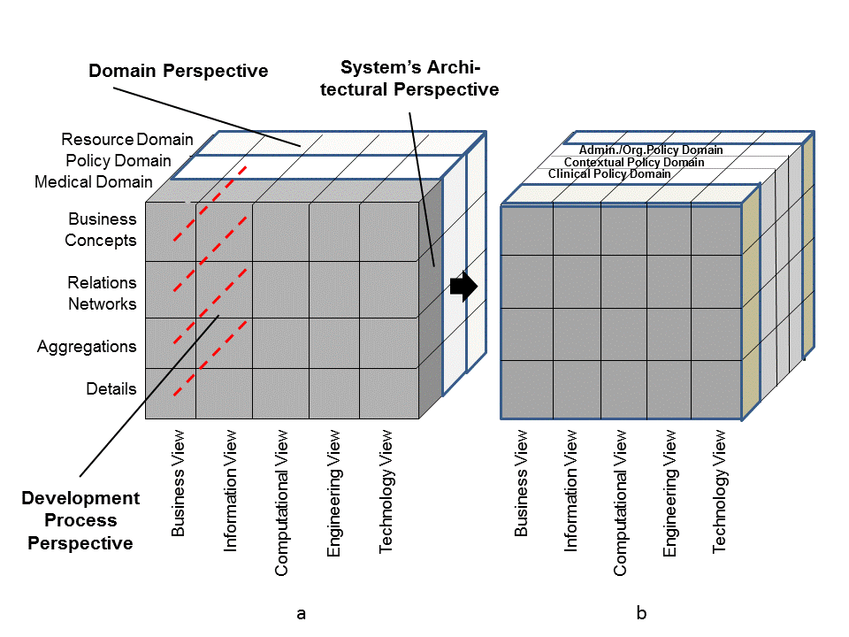 | 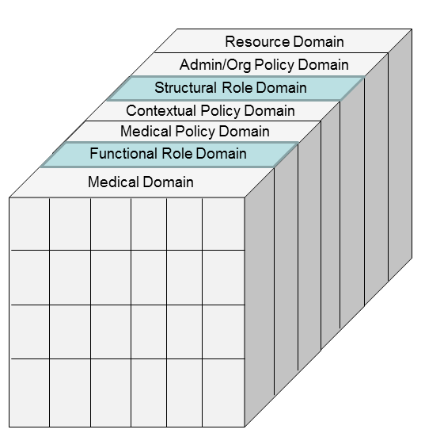  c

Figure 1 – Representation of the role concepts defined in this standard using the Generic Component Model (after [5], modified]
The principles established in this International Standard are also applicable to domains other than healthcare. In that case, that domain and its related policy domain have to be entered in Figure 1c.
The development of components, their concept representation and their aggregation are based on constraint modeling. Concepts and rules can be represented using meta-languages such as UML and UML derivates or the XML languages set.

Roles and policy aspects
Roles are components reflecting specific aspects of a system. They have to be managed according to all dimensions of the GCM. As policies are properties and functions in another system/component dimension, policies have to be embedded in the component specification through corresponding constraints. Interrelated classes and associations can be simplistically modeled by component attributes and operational constraints. This is e.g. done in some simplistic RBAC (Role-Based Access Control) specifications ignoring the policy-driven correct approach. Associating, e.g., a functional role class with the related policy class defining context and other constraints to access target objects, the resulting component can summarize those constraint in a permission bound to this role and expressed as permission attribute.
For managing relationships between the entities, structural (organisational) and functional roles can be defined. Roles might be assigned to any entity as an actor in a communication or cooperation interrelationship (e.g. person, organization, system, device, application, component, etc.). Because entities are actors in use cases, roles have relationship to actors and therefore to actions. Functional and structural roles are associated with and defined by policies.
A policy may describe the legal framework including rules and regulations, the organisational and administrative framework, functionalities, claims and objectives, the entities involved, agreements, rights, duties, and penalties defined as well as the technological solution implemented for collecting, recording, processing and communicating data in information systems.
Policies can be specified and implemented in different ways, including:
- in a policy agreement as specified in ISO 22600-1
- as an attribute
- as an implicit policy as part of another component
- as a separate policy element to be combined with another component or used directly
- as a rule policy combined with another policy
- as structured expressions (e.g. using XACML)

A policy may be applied as a set of rules describing constraints on components, their functions and relations, i.e., the behavior, of a system. Health information systems such as the Electronic Health Record (EHR), for instance, should have one policy per Structural Role as well as one policy per Functional Role. Further details regarding policy specification and the relationship to privilege management and access control are provided in ISO 22600.
Roles can be instantiated through numerous mechanisms, including directory entries, database variables, certificates among others Role assignment certificates may be attribute certificates or public-key certificates. Specific privileges are assigned to a role rather than to individual through role specification certificates. The indirect assignment enables the privileges assigned to a role to be updated, without impacting the certificates that assign roles to individuals. Role specification certificates must be attribute certificates, and not public-key certificates. If role specification certificates are not used, the assignment of privileges to a role may be done through other means (e.g. may be locally configured at a privilege verifier).
The following are all possible:
- any number of roles can be defined by any Attribute Authority;
- the role itself and the members of a role can be defined and administered separately, by different Attribute Authorities;
- a privilege, may be delegated; and
- roles may be assigned any suitable lifetime.
Further discussion regarding assignment of multiplicity of structural and functional roles is addressed in the discussion of structural and functional roles below. Further details regarding the expression of roles through digital certificates are provided in ISO 17090. Further details regarding the representation of roles as a directory entry are provided in ISO/IEC 21091.
Functional and structural roles are associated with and defined by policies.

Roles in privilege management
Privileges can be assigned to an individual by a role assignment, or directly. A role can be expressed in public key certificates, attribute certificates or in a directory entry as described in ISO 17090 and ISO 21091.If the role assignment certificate is a public-key certificate, the role attribute is contained in the subjectDirectoryAttributes extension. In the latter case, any additional privileges contained in the public-key certificate are privileges that are directly assigned to the certificate subject, not privileges assigned to the role. If the role assignment certificate is an attribute certificate, the role attribute is contained in the attributes component of the attribute certificate.
Thus, a privilege asserter may present a role assignment certificate to the privilege verifier demonstrating only that the privilege asserter has a particular role (e.g., "manager", or "purchaser"). The privilege verifier may know a priori, or may have to discover by some other means, the privileges associated with the asserted role in order to make a pass/fail authorisation decision. The role specification certificate can be used for this purpose.
A privilege verifier must have an understanding of the privileges specified for the role. The assignment of those privileges to the role may be done within the Privilege Management Infrastructure (PMI) in a role specification certificate or outside the PMI (e.g. locally configured). If the role privileges are asserted in a role specification certificate, mechanisms for linking that certificate with the relevant role assignment certificate for the privilege asserter are provided in this Specification. A role specification certificate cannot be delegated to any other entity. The issuer of the role assignment certificate may be independent of the issuer of the role specification certificate and these may be administered (expired, revoked, and so on) entirely separately. The same certificate (attribute certificate or public-key certificate) can be a role assignment certificate as well as contain assignment of other privileges directly to the same individual. However, a role specification certificate must be a separate certificate.
NOTE The use of roles within an authorisation framework can increase the complexity of path processing, because such functionality essentially defines another delegation path which must be followed. The delegation path for the role assignment certificate may involve different AAs and may be independent of the AA that issued the role specification certificate.

Relations of this standard to related privilege management specifications
The role concepts defined in this standard are referenced and reused in many international standards created, e.g., by ISO, CEN, HL7 International dedicated to privilege management solutions. Examples are ISO 22600 “Health informatics – Privilege management and access control”, HL7 International “HL7 Healthcare privacy and security classification system (HCS)” [6], HL7 International “The HL7 RBAC Healthcare Permission Catalog” [7].
Starting point for privilege management solutions is frequently a role-based access control (RBAC) as defined at the US National Institute for Standards (NIST). Considering functional roles in addition to the commonly used structural roles, this RBAC can be refined as specified in the HL7 RBAC Health care permission catalog [7]. An intermediate solution for flexible and scalable automated security and privacy management, the HL7 Healthcare Privacy and Security Classification System (HCS) – Release 3 [6] has been standardized in 2013 by HL7 International. A sophisticated solution is specified in ISO 22600 Health informatics - Privilege management and access control. The latter solution defines the rules required for assuring security and privacy as ontology-based, explicit policies. Those policies flexibly consider contextual and environmental conditions as well as individual preferences at any level of granularity, thereby supporting comprehensive interoperability. The specifications mentioned here can be accessed at HL7 International on www.hl7.org.

Structural roles

General
In general, two types of roles can be distinguished: structural roles and functional roles. Structural roles reflect the structural/organizational aspects of relationships between entities (e.g. person-person or person-organization relationships, as happening in employment context, organizational hierarchies, responsibilities, etc.). They enable certain services within the generic structure-function relationship. Many structural roles may be assigned to a single entity reflecting the same entities relationship to several other entities and/or different context constraints (e.g. structural roles of a person as head physician, director of a healthcare establishment, specialized ophthalmologist, etc.).
Where structural roles reflect human or organisational categories, the structural roles may representprerequisites, skills, or competencies of entities associated with the roles as identified or guaranteed by the organisations which scope these roles to interact within their particular functional role. Concepts and functions bound to a structural role are depending on the underlying policy. Therefore, structural roles differ from policy domain to policy domain within and across organisational boundaries, and especially between different jurisdictions and countries.
Structural roles persist with the persistence of the relationship between those entities and the related policies despite whether the assigned responsibilities and functions are performed or not.
As structural roles comprise rather complex business processes, structural roles usually relate to higher levels of complexity in the Generic Component Model (Figure 1).

Structural roles of healthcare professions from the International Labour Organization
One set of functional roles useful for authorisations and access rights is the International Standard Classification of Occupations 2008 (ISCO-08). In order to enable international interoperability, the following structural roles shall be used where more specific structural roles known to the communicating parties are unavailable. The vocabulary identification for this list of coded values shall be referenced by the following OID:
Vocabulary Identification: iso (1) standard (0) functional and structural roles (ISO 21298) structural role vocabulary (1)

This structural role vocabulary is reflected in the CodedData of the hcRole attribute as described in ISO/FDIS 17090. An example is provided in the annex of this document to further clarify this usage.
This structural role vocabulary may be used for international interoperability for the coding system indicated in the HCProfessional object class, HCProfession attribute as described by ISO 21091.
This structural role vocabulary may be used for recording the internationally recognized role of the individual involved in health related transactions in associated audit logs.
This vocabulary is freely available from the International Labor Organization (ILO) and is therefore not replicated in this International Standard. An annex is provided with an example of possible mappings for several national regulated healthcare professions.
Each jurisdiction or domain is responsible for mapping their local structural roles to the internationally recognized structured vocabulary identified. Policy mapping shall be used to negotiate the specifics of these roles between jurisdictions. If there are any interpretation differences between two parties entering into an exchange, then these differences must be reconciled through policy agreement (see ISO 22600-1 as an example of a policy model)

This vocabulary shall be used to specify the structural role associated with the following Healthcare Person regulatory status classification (Table 1):
Vocabulary Identification: iso (1) standard (0) Healthcare Person regulatory status (2) for roles defined in this standard.

Table 1 – Vocabulary for specifying structural roles associated with healthcare person regulatory status
Reg_status_id | Reg_status_name | description
01 | regulated health professionals | person who is authorized by a nationally recognized body to be qualified to perform certain health services [ISO FDIS17090-1:2013]  EXAMPLES Physicians, registered nurses and pharmacists.  NOTE 1 The types of registering or accrediting bodies differ in different countries and for different professions. Nationally recognized bodies include local or regional governmental agencies, independent professional associations and other formally and nationally recognized organizations. They may be exclusive or non-exclusive in their territory.  NOTE 2 A nationally recognized body in this definition does not imply one nationally controlled system of professional registration but, in order to facilitate international communication, it would be preferable for one nationwide directory of recognized health professional registration bodies to exist.
02 | non-regulated health professionals | person employed by a healthcare organization, but who is not a regulated health professional [ISO/FDIS 17090-1:2013]  EXAMPLES Receptionist or secretary who organizes appointments, or a business manager who is responsible for validating a subject of care’s health insurance.  NOTE The fact that the employee is not authorized by a body independent of the employer in his professional capacity does, of course, not imply that the employee is not professional in conducting his services.
03 | sponsored healthcare providers (NOTE: this category s used to reflect Health care professionals under training) | health services provider who is not a regulated professional in the jurisdiction of his/her practice, but who is active in his/her healthcare community and sponsored by a regulated healthcare organization [ISO/FDIS 17090-1:2013]  EXAMPLES A drug and alcohol education officer who is working with a particular ethnic group, or a healthcare aid worker in a developing country.
04 | supporting organization employees | person employed by a supporting organization [ISO/FDIS 17090-1:2013]  EXAMPLES: Medical records transcriptionists, healthcare insurance claims adjudicators and pharmaceutical order entry clerks.

Medical specialties
Structural roles describing medical professions may be further classified by medical specialty. Medical specialties are typically associated with medical doctors, but may also be used to qualify the structural roles associated with nursing, and other healthcare professions or supporting roles.
The following medical specialties, adopted from the World Health Organization World Alliance for Patient Safety interim work efforts (unpublished), shall be used for such sub-classification to enable international interoperability (Table 2):
Vocabulary Identification: iso (1) standard (0) medical specialty vocabulary (3) for roles defined in this standard.

Table 2 – Vocabulary for specifying structural roles associated with medical specialities
role_identifier | role_name | description
01 | Anaesthesia | The medical specialty concerned with the pharmacological, physiological, and clinical basis of anaesthesia (pharmacologic depression of nerve function or from neurologic dysfunction) and related fields, including resuscitation, intensive respiratory care, and acute and chronic pain
02 | Administrative Services | The organisational services pertaining to, or designed to deal with, the conduct or management of organisational affairs
03 | Allied Health | The health profession comprised of qualified health professionals trained to assist, facilitate, or complement the work of physicians, dentists, podiatrists, nurses, pharmacists and other specialists in the health care system.
04 | Dietetics | The health profession concerned with the practical application of diet in the prophylaxis and treatment of disease
05 | Breast Surgery | The surgical specialty concerned with the treatment of breast and associated tissue disease, injury and deformity by physical operation or manipulation.
06 | Cardiothoracic Surgery | The branch of medicine concerned with treatment of heart and thorax disease, injury and deformity by physical operation or manipulation.
07 | Cardiology | The medical specialty concerned with the diagnosis and treatment of heart disease.
08 | Gerontology (also referred to as geriatrics) | The branch of medicine concerned with prevention, treatment of medical problems, and care of the aged (usually 65 years of age or older).
09 | Clinical Immunology and Allergy | The specialty concerned with the structure and function of the immune system, various phenomena of immunity, induced sensitivity and allergy.
10 | Dental Medicine and Surgery | The specialty related to the function and diseases of the teeth, mouth and gums._
11 | Dermatology | The branch of medicine concerned with the study of the skin, nails and hair, diseases of the skin, nails and hair, and the relationship of coetaneous lesions to systemic disease.
12 | Diagnostic Services | The services related to the determination of the nature of a disease or injury.
13 | Emergency Medicine | The branch of medicine related to the diagnosis and treatment of conditions arising suddenly and unexpectedly, calling for prompt action and requiring immediate treatment.
14 | Endocrinology | The science and medical specialty concerned with the internal or hormonal secretions and their physiologic and pathologic relations.
15 | Gastroenterology | The medical specialty concerned with the function and disorders of the gastrointestinal tract, including stomach, intestines and associated organs.
16 | General Medicine | The branch of medicine involving the study and treatment of general diseases or those affecting the internal parts of the body, especially those not usually requiring surgical intervention.
17 | General Nursing | The branch of healthcare concerned with caring for the sick or injured in any environment
18 | General Surgery | The branch of medicine concerned with treatment of disease, injury or deformity by the performance of invasive procedures, physical operation or manipulation.
19 | Genetics | The branch of medicine concerned with applying the science of the means and consequences of transmission and generation of components of biologic inheritance and the genetic features and constitution of a single or set of organisms to diagnosis, prognosis, management and prevention of genetic diseases.
20 | Gynaecology | The medical specialty concerned with the diseases of the female genital tract, as well as endocrinology and reproductive physiology of the female.
21 | Haematology | The medical specialty concerned with the anatomy, physiology, pathology, symptomology and therapeutics related to the blood and blood-forming tissue.
22 | Infectious Diseases | The medical specialty concerned with the prevention and treatment of diseases caused by micro-organisms capable of being transmitted from person to person, with or without actual contact
23 | Intensive Care | The specialty related to advanced and highly specialised care provided to medical or surgical subjects whose conditions are life threatening and require comprehensive care and constant monitoring
24 | Maxillo-facial Surgery | The surgical specialty concerned with the treatment of diseases of the mouth, jaw and face by the performance of physical operation or manipulation
25 | Neonatology | The paediatric specialty concerned with the systematic evaluation and treatment of the newborn (relating to the period immediately succeeding birth and continuing through the first 28 days of extra-uterine life), including premature newborns.
26 | Nephrology/Renal | The branch of medical science concerned with medical diseases of the kidneys
27 | Neurology | The branch of medical science concerned with the various nervous systems (central, peripheral, and autonomic), plus the neuromuscular junction and muscle, and their disorders
28 | Neurosurgery | The surgical specialty concerned with the treatment of diseases of the brain, spinal cord, spinal column, and peripheral nerves through the performance of physical operation or manipulation
29 | Obstetrics | The medical specialty concerned with the care of women during pregnancy, parturition, and the puerperium.
30 | Oncology | The medical and/or surgical specialty concerned with the study or science dealing with the physical, chemical, and biologic properties and features of malignant neoplasms, including causation, pathogenesis and treatment.
31 | Ophthalmology | The medical specialty concerned with the eye, its diseases, and refractive errors
32 | Orthopaedics | The surgical specialty concerned with the treatment of acute and chronic disorders of the musculoskeletal system, including injuries, diseases, dysfunction, and deformities (orig. deformities in children) in the extremities and spine.
33 | Otolaryngology | The specialty concerned with diseases of the ear and larynx, including the upper respiratory tract and diseases of the head and neck, tracheobronchial tree, and esophagus
34 | Pain Services | The specialty concerned with the control and regulation of pain, especially through the use of medication.
35 | Palliative Medicine | The specialty concerned with providing treatment to reduce the severity of and/or alleviate symptoms without curing the underlying disease.
36 | Paediatrics | The medical specialty concerned with the study and treatment of children in health and disease during development from birth through adolescence.
37 | Pharmacy | The branch of medical science that deals with drugs and their uses.
38 | Physiotherapy (also referred to physical therapy) | The health profession concerned with promotion of health, with prevention of physical disabilities, with evaluation and rehabilitation of persons disabled by pain, disease, or injury, and with treatment by physical therapeutic measures as opposed to medical, surgical, or radiologic measures.
39 | Plastic Surgery | The surgical specialty concerned with the restoration, construction, or reconstruction of the shape and appearance of body structures that are missing, defective, damaged, or misshapen.
40 | Podiatry | The health profession concerned with the diagnosis and/or medical, surgical, mechanical, physical, and adjunctive treatment of the diseases, injuries, and defects of the human foot.
41 | Primary Care | The medical specialty concerned with providing and managing basic routine health care.
42 | Psychiatry | The medical specialty concerned with the diagnosis and treatment of mental disorders.
43 | Public Health | The health profession concerned with protecting, promoting, restoring and improving the health of a community through disease prevention, health education, control of communicable diseases, application of sanitary measures and monitoring environmental hazards.
44 | Rehabilitation | The medical specialty concerned with the diagnosis and treatment of subjects of care with impairments or disabilities, focusing primarily on maximal restoration of physical, psychological, social and vocational functions and the alleviation of pain.
45 | Radiation Oncology | The medical specialty concerned with the use of ionizing  radiation in the treatment of neoplasms.
46 | Rheumatology | The medical specialty concerned with the study, diagnosis, and treatment of various conditions with pain or other symptoms of articular origin or related to other elements of the musculoskeletal system.
47 | Speech and Language Therapy | The health profession concerned with functional and  organic speech, language, oral and pharyngeal sensorimotor, cognitive or communicative defects and disorders.
48 | Thoracic/Respiratory Medicine | The medical specialty concerned with the diagnosi and treatment of conditions affecting the upper part of the trunk between the neck and the abdomen containing the chief organs of the circulatory and respiratory systems.
49 | Vascular Surgery | The surgical specialty concerned with the diagnosis and treatment of diseases related to the circulatory system (the blood vessels in the cardiovascular and Lymphatic systems collectively).
50 | Urology | The medical specialty concerned with the diagnosis, and treatment of diseases of the adrenal gland and reproductive and urinary systems and adjoining structures.
51 | Other specialty not elsewhere classified

When a jurisdiction or domain uses this standard, it will need to map their medical specialties to the internationally recognized structured vocabulary identified to assure compatibility. Policy mapping shall be used to negotiate the specifics of these specialties between jurisdictions. If there are any interpretation differences between two parties entering into an exchange, then these differences must be reconciled through policy agreement (see 22600/1 as an example of a policy model)

Functional roles
Functional roles are bound to the realisation/performance of actions performed by an entity. Regarding the healthcare business process, functional roles can be defined in relation to the care or administrative process. One entity may perform as a single functional role in a single act only. In a security and privacy context, these functional roles may be bound to policies representing different levels of authorisations and access rights. Because the functional role is bound to the action, once the action has been completed, the corresponding relationship between the entity and the functional role associated with the action ends. .
The assignment of a structural role is an activity performed by two interacting entities playing action-bound functional roles (see section 6.2.).
As functional roles comprises rather business functions, services or simply transactions (basic business concepts), functional roles relate to lower levels of complexity in the Generic Component Model (Figure 1).
Further details regarding the role engineering process and related policies can be found in the ISO 22600.
One set of functional roles useful for modeling authorisations and access rights is the following list which shall be used for international interoperability where more specific functional roles are unavailable (Table 3):
Functional roles coded values vocabulary Identification: iso (1) standard (0) functional and structural roles (21298) functional role vocabulary (4)

Table 3 – Vocabulary for specifying high level functional roles
role_identifier | role_name | description
01 | Subject of care | recipient of care services
02 | Subject of care agent | e.g. parent, guardian, carer, or other legal representative  NOTE: some jurisdictions may use different terms to describe this role (e.g. Subject of care proxy)
03 | Personal healthcare professional | healthcare professional or professionals with the closest relationship to the subject of care, often the subject of care’s GP
04 | Privileged healthcare professional | nominated by the subject of care  OR  nominated by the healthcare facility of care (if there is a nomination by regulation, practice, etc. such as an emergency over-ride)
05 | Healthcare professional | party involved in providing direct care to the subject of care
06 | Health-related professional | party indirectly involved in caring the subject of care (teaching, research, etc.)
07 | Administrator | any other parties supporting service provision to the subject of care

This identifies a high-level list of functional roles to enable interoperable exchanges across jurisdictional or domain boundaries. This can be applied to manage the creation, access, processing, and communication of health information. More granular functional roles may be asserted within a domain or jurisdiction or may be agreed upon for communications between such domains or jurisdictions.
Additionally, functional roles can be grouped according to the relation to the information created, recorded, entered, processed, stored, and communicated:
- Composer
- Committer
- Certifier
- Signer
- Authoriser
- Subject of information
- Information provider
Examples for low level functional roles (aggregations or even details in the GCM) are
- Prescriber
- Observer
- Diagnostician
- Therapist

Formally modelling roles (informative)

Roles within the Generic Component Model
In the context of an entity to entity interrelationship mediated by a common act, roles are used to qualify the association, therefore established as association classes. For harmonization with HL7’s modeling approach where association classes could not be expressed (before moving towards UML after introducing the Model Interchange Framework MIF), roles have been introduced as HL7 RIM classes, qualifying the Entity-Act association through Functional Roles at the Act side and Structural Roles at the Entity side.
Structural roles correspond to the ISO/HL7 21731 “Health informatics – Reference Information Model (RIM)” RIM Role_Class, while the functional roles correspond to the ISO/HL7 21731 “Health informatics – Reference Information Model (RIM)” Participation_Class. The relationship between entities mediated by structural roles has been expressed at the ISO/HL7 21731 “Health informatics – Reference Information Model (RIM)” RIM Role_Relationship_Class. Security and privacy related specifications provided by HL7 International such as the “HL7 Healthcare privacy and security classification system (HCS)” [6], “The HL7 RBAC Healthcare Permission Catalog” [7], or the HL7 Composite Security and Privacy Domain Analysis Model [8] refer to the definitions provided in this standard.
The aforementioned Generic Component Model specifies a component-based and service oriented architecture for any domain. Within that domain, the component model can be appropriately applied by decomposing it from Business Concepts level over Relations Network, Basic Services/Functions down to Basic Concepts. Thus, a business process is refined considering the workflows and resulting activities and functions up to the transactions performed. Dedicating roles to the different business process levels is called Role Engineering (Figure 1). Starting with this computation-independent model of real systems, the different views of open distributed systems are considered according to ISO 10746 Information technology – Open Distributed Processing – Part 2: Reference Model. Further details of the modelling approach and policy driven role based access control can be found in the ISO 22600 mentioned above.

Developing the role model

Relationships and transformation
Expressing this in UML, the many-to-many relationships between entities and acts can be transformed according to Figure 2.
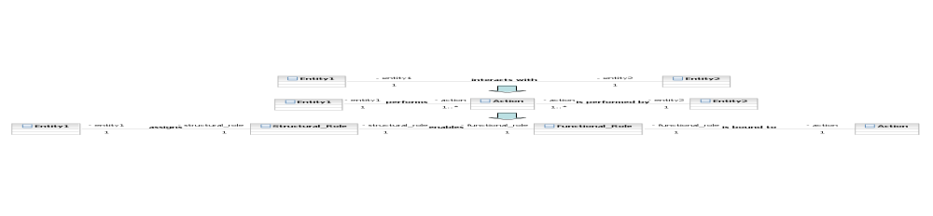
Figure 2 – Development of the role model

Assignment of Structural Roles
A relationship between to entities may be the result of a contractual agreement act between the entities playing specific functional roles (see below). Such a contract could define the structural role as being, for instance, a head physician. Another example would be an Entity-Entity relationship for education whereby a special qualification is granted as well as a certification act resulting in a certificate certifying this qualification as a structural role.
This structural role constrains another Entity-Entity relationship influencing the functional role played by the entities involved in an activity. Structural roles are established as an act between entities according to specific act-related functional roles. This is depicted in Figure 3, which describes the assignment process and the deployment process of structural roles.
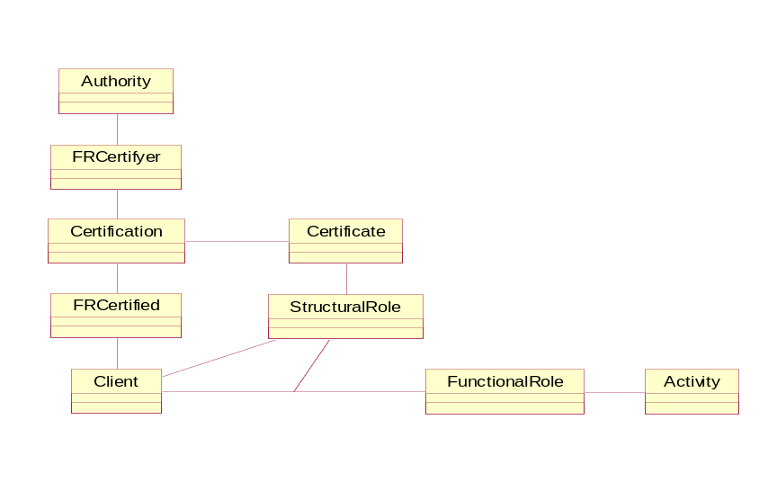
Figure 3 – Establishment of a structural role within an act according to specific functional roles
Considering both structural roles and functional roles in the same context, structural roles provide the prerequisites/competencies for entities to perform interactions (an act) within their specific functional roles. Qualifications, skills, etc., are influencing both the assignment of the structural roles and the performance of activities according to their functional roles.

Generic role specification
Figure 4 describes a role using XML.

Figure 4 – Role specification
Table 4 describes the RoleClass attributes. The provided data type definition resembles the HL7 Version 3 Data type Definition Error: Reference source not found.
Table 4 – RoleClass attributes
Attribute | Type | Remarks
role_identifier | SET <II> | Set of InstanceIndentifier
role_name | CS | CodedSimpleValue
authority_identifier_ID | OID | ISO ObjectIdentifier
authority_identifier_name | ST | String
role_description | CD | ConceptDescription

As shown in Figure 4, role_description provides a typed concept description, e.g., representing typed rules (policies), thereby enabling flexibility and extensibility by preserving interoperability. As policies describe any legal, social, ethical, functional, and technical implication of a system’s and its components’ security, privacy and safety, policies are used to describe the related dimensions in the Generic Component Model, i.e., constraints on considered components, their functions and interrelations. In that context, the medical domain of, e.g., creating, storing, processing, retrieving, and communicating Electronic Health Records (EHR) has to be combined with the ethico-legal domain, fixing requirements and conditions for the operation of such an EHR system. Therefore, all classes in the interaction chain reflecting certain domains’ perspectives have to be connected to corresponding policy classes ruling the former classes’ behavior. The ISO 22600 “Health informatics – Privilege management and access control” has introduced a policy model meeting the requirements of the Generic Component Model (Figure 5). More details about modeling and use of policies in the security, privacy, and safety context can be found in the aforementioned ISO 22600 specification.

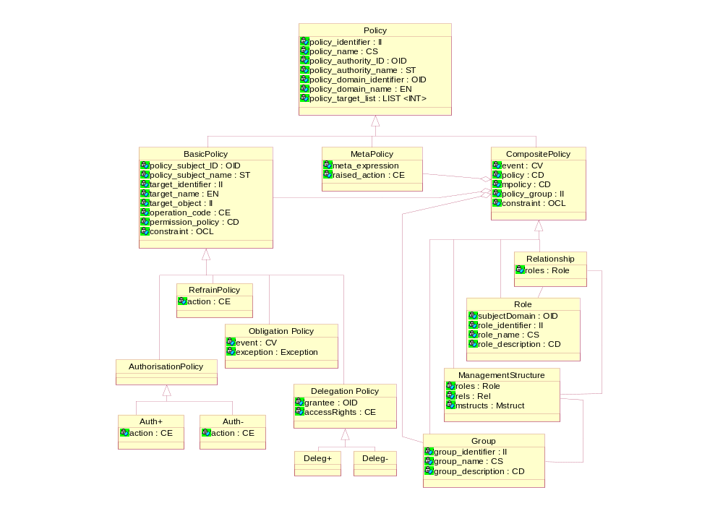
Figure 5 – Policy Model
As components representing different domain relations, granularity levels, or viewpoints of a system and its components can be aggregated, the resulting component presents structure and behavior of the component under consideration under the constraints of the interfering component and the corresponding association. Assuming simple constraining rules, attributes of the interfering class can be expressed as additional attribute in the considered component’s class. Combined with certain constraining operations, an additional attribute and related constraints for its instances can be defined, reducing the system’s complexity. An example for such component composition using UML could be the aggregation of a functional role component and the related policy component resulting in a combined role_policy_class representing the policy rules by a simple permission attribute in an “extended role class” as defined in the NIST RBAC approach. Such simplification demonstrates the applicability of the models offered in this standard and the related specifications, even if the richness of the approach goes far beyond.
Simple policies widely introduced and used in the security domain are, e.g., separation of duties, other administrative, organizational, or time constraints, etc. For example, authorisation restrictions may be applied by policy that requires constraints related to:
- cardinality
- time of day
- static and dynamic separation of duties
See section 5.1 for an overview of the relationship between roles and policies as well as ISO 22600 for details regarding policy and privilege management.

Relationships between Structural and Functional Roles
In general, two types of roles can be distinguished: structural roles and functional roles. Structural roles reflect the structural aspects of relationships between entities. Structural roles describe prerequisites, skills, or competencies for acts. Functional roles reflect functional aspects of relationships between entities. Functional roles are bound to the realisation/performance of acts.
Considering both structural roles and functional roles in the same context, structural roles provide the prerequisites/skills/competencies for entities to perform interactions (an act) within their specific functional roles.
In the Generic Component Model described in ISO 22600, the component specification and the aggregation rules are defined by policies through constraint modelling. This can lead to a great level of complexity due to the large number of specialisations and different grouping rules.
Direct semantic interoperability can be achieved within a common policy domain or where multiple policy domains express the same policy to implement the underlying business rules. Otherwise, interoperability has to be provided through policy bridging (negotiation of policy agreements). The highest achievable level of the harmonization of the roles is determined by the highest commonality within the underlying business rules and the policies used to implement those rules. For instance, within a company or within one administrative domain (e.g. a Physicians’ Chamber’s area), it would be possible to implement a common policy leveraging consistent structural roles. At some lower level of complexity, such role definition could be harmonised in one or several countries. Globally, ideally we would all operate with common professions (structural roles) and policies, only functional roles as a least common denominator can be harmonised.
While ignoring explicit policy definitions and binding, the HL7 RBAC Task Force provided a role engineering example by defining functional and transactional permissions for US-related structural roles [7].

Use cases for the use of structural and functional roles in an interregional or international context (informative)
An organisational entity, through an authorised representative, assigns a structural role to an employee for whom organisational policy defines his/her privileges and duties. Where this is delivered as a role certificate, the role certificate would be delivered as part of an employment contract that expresses the underlying policy applicable for that role. Such a policy might also refer to other policies to which the subject of the assigned role must conform such as legislation, regulations, etc. This structural role is typically related to certain formal or informal qualifications such a medical license or other clinical credentials. A structural role certificate may be directly bound to a qualification (e.g. certified physician). Alternatively, the structural role may reflect an individual’s job or position within the organisation (e.g. Head of Cardiology). Based upon the assigned structural role (e.g. Head of Department), the role owner performs in the enterprise context in all business cases according to this structural role. This might cover a series of basic functions (performed under functional roles) such as hiring staff members, assigning structural roles within a policy domain, planning, preparing, controlling processes, planning activities and functions, managing infrastructure, or managing resources such as budgets. Concepts and functions bound to a structural role depend on the underlying policy. Therefore, structural roles differ from policy domain to policy domain within and across organisational boundaries, and especially between different jurisdictions and countries.
For example, in an emergency case such as a traffic accident, a person (living entity) performs according to his/her structural role (e.g. as physician (2211) or nurse (2221) ) or following ethical principles or legal challenges without explicit role assignment in the functional role of Healthcare professional (05) in order to care the accident’s victims. Once the action associated with the functional role has been performed, the functional role disappears.
Within a clinical workflow, a physician (2211) performs a prescription as part of his/her structural role obligations dedicated to a specific subject of care in a specific case of care. In one policy domain with a common understanding of the different transactions performed in the context of a prescription action/function, the locally defined functional role of prescriber (locally coded) can be communicated and used for semantic interoperability. Because of differences regarding the required transactions to perform a prescription in different jurisdictions, the prescription action/function can be refined towards the transactions involved such as substance administration or signing a prescription. For international semantic interoperability, the functional role would be Healthcare professional (05), and the structural role would by Medical Doctor (2211). Cross-jurisdiction recognized transactions may be agreed upon through the policy agreement process to enable interoperable prescription signing functions at a more detailed functional role level. Coarse-grained roles (e.g. structural roles) require harmonisation of underlying policies, while fine-grained roles (functional roles used at the transaction level) are suitable for global communication and cooperation. For establishing a cooperative framework, we leverage the highest level of common policy.
In a RBAC model of an EHR, the member of a therapeutic team, functional role Healthcare professional (05), might include a midwife (2222) in one country, but it might exclude this particular healthcare professional in another country, classifying him or her as another functional role, Health-related professional (06). If interoperability is to be achieved, the privileges and obligations of each different healthcare professional must be examined, and a common consensus must be achieved through policy agreement between these two jurisdictions.
- (informative)
ISCO-08 Sample Mapping
Sample mapping of multiple national regulated professionals to ISCO-08:
ISCO-08 | SNOMED-CT | Japan | France | Finland | Ontario | The Netherlands | Australia
2211 Generalist medical practitioners (including District medical doctor – therapist, Family medical practitioner, General practitioner, Medical doctor (general), Medical officer (general), Resident medical officer specializing in general practice, Physician (general), Primary health care physician) | 112247003 | ‘Medical Doctor’ | GPs | physician | Physicians and Surgeons | Physicians | Medical practitioner
2212 Specialist medical practitioners (including Anaesthetist, Cardiologist, Emergency medicine specialist, Gynaecologist, Obstetrician, Ophthalmologist, Paediatrician, Pathologist, Preventive medicine specialist, Psychiatrist, Radiologist, Resident medical officer in specialist training, Specialist physician (internal medicine), Surgeon, etc) | 69280009 |  | specialists
2261 Dentists (including Dental Practitioner, Dental Surgeon, Dentist, Endodontist, Oral and Maxillofacial Surgeon, Oral Pathologist, Orthodontist, Paedodontist, Periodontist, Prosthodontist, Stomatologist | 106289002 | ‘Dentist’ | Dental surgeons Interns | dentist | Dental Surgeons | Dentists | Dentist  Dental specialist
2262 Pharmacists (including Dispensing chemist, Hospital pharmacist, Industrial pharmacist, Retail pharmacist) | 46255001 | ‘Pharmacist’ | Pharmacists | head dispenser, pharmacist | Pharmacists | Pharmacists | Pharmacists
2131 Biologists, botanists, zoologists and related professionals (including Animal Behaviourist, Bacteriologist, Biologist, Biotechnologist, Botanist, Cell Geneticist, Marine Biologist, Microbiologist, Molecular Biologist, Molecular Geneticist, Zoologist, Pharmacologist) | 31641003
3213 Pharmaceutical technician (including Pharmaceutical technician, Pharmaceutical assistant) | 159040006 |  | Pharmaceutical Assisstant
3212 Medical and pathology laboratory technicians (including Blood-bank technician, Cytology technician, Medical laboratory technician, Pathology technician) | 159285000 | ‘Medical Technologist’  ‘Clinical Laboratory Technician’ |  | medical laboratory technologist | Medical Laboratory Technologist |  | Medical technologist  Clinical laboratory technologist
2119 Forensic science technician | 159285000
3211 Medical imaging and therapeutic equipment technicians (including - Diagnostic medical radiographer, Mammographer, Medical radiation therapist, Nuclear medicine technologist, Sonographer) | 386626000 | ‘Radiological Technologist’ | Radiation Technologist, Manipulateur d'electroradiologie medicale | radiographe | Medical Radiation Technologists |  | Medical radiation practitioner  Diagnostic radiographer  Nuclear medicine technologist  Radiation therapist  Sonographer
2221 Nursing professionals (including Clinical nurse, District nurse, Nurse anaesthetist, Nurse educator, Nurse practitioner, Professional Nurse, Public health nurse, Specialist nurse) | 224569005 | ‘General Nurse’  ‘Public Health Nurse’ | Nurses | nurse  public health nurse | Nurses | Nurses | Registered nurse
2222 Midwifery professionals (including Professional midwife) | 106294002 | ‘Midwife’ | Midwifes | midwife | Midwives | Midwives | Midwife
2264 Physiotherapists (including Geriatric physical therapist, Paediatric physical therapist, Orthopaedic physical therapist, Physiotherapist) | 36682004 | ‘Physical Therapist’ | Physiotherapists | physiotherapist | Physiotherapists | Physiotherapists | Physiotherapist
2269 Health professionals not elsewhere classified (including Arts therapist, Dance and movement therapist, Occupational therapist, Podiatrist, Recreational therapist, etc) | 309398001 | ‘Occupational Therapist’ | Occupational Therapist  Podiatrist  Psychomotrician | occupational therapist  protected occupational title: podiatrist, protected occupational title: chiropodist | Occupational Therapists  Chiropodists |  | Occupational therapist  Podiatrist  Medical laboratory scientist  Clinical scientist
2267 Optometrists and ophthalmic opticians (including Ophthalmic Optician, Optometrist, Orthoptist) | 28229004 | ‘Orthoptist’ | Orthoptists  Optician | optician | Optometrist  Opticians |  | Optometrist  Orthoptist
2266 Audiologists and speech therapists (including Audiologist, Language therapist, Speech therapist, Speech, Pathologist) | 159026005 | ‘Speech Therapist’ | Speech and language pathologist | speech therapist | Audiologists and Speech-Language Pathologists | Speech Pathology, Audiologist, Speech Pathology | Audiologists  Speech pathologist
3214 Medical and dental prosthetic technicians (including Dental technician, Denturist, Orthotic technician, Orthotist, Prosthetic technician, Prosthetist) | 309428008 | ‘Dental Technician’  Prosthetics & Orthctic’  ‘Artificial limb fitter’ | Audioprothesist Prothésiste dentaire/technicien dentaire  Prosthetist, Orthotist | dental technician | Dental Technologists |  | Audiometrist Dental prosthetist  Dental technician  Orthotist/ prosthetist
3221 Nursing associate professionals (including Associate professional nurse, Assistant nurse, Enrolled nurse, Practical nurse) | 224576000 |  |  |  |  |  | Enrolled nurse
3222 Midwifery associate professionals (including Assistant midwife, Traditional midwife) | 309452001 |  |  |  |  |  | Mothercraft nurse
2265 Dieticians and nutritionists (including Clinical dietician, Food service dietician, Nutritionist, Public health nutritionist, Sports nutritionist) | 159033005 | ‘National Registered ‘Dietitian’ | Dieticians | dietitian | Dieticians |  | Dietician  Nutritionist
2635 Social work and counselling professionals (including Addictions counsellor, Bereavement counsellor, Child and youth counsellor, Family counsellor, Marriage counsellor, Parole officer, Probation officer, Social worker, Women’s welfare organizer) | 106328005 | ‘Certified Social Worker’ | Assistant en service social |  |  |  | Social worker  Welfare support worker
5321 Health care assistants, Nursing aide (including Birth assistant (clinic or hospital), Nursing aide (clinic or hospital), Patient care assistant, Psychiatric aid, etc) | 224577009 | ‘Certified Care Worker’ |  |  |  |  | Nursing support worker  Personal care assistant  Aged or disabled care worker.
5322 Home-based personal care workers (including Home care aide, Home birth assistant, Nursing aide (home), Personal care provider, etc) | 224577009
2240 Paramedical practitioner (including Advanced care paramedic, Clinical officer (paramedical), Feldscher, Primary care paramedic, Surgical technician) | 397897005
3258 Ambulance workers (including Ambulance officer, Ambulance paramedic, Emergency medical technician, Emergency paramedic) | 409971007 | ‘Emergency Medical Technician’ |  | protected occupational title: hospital and ambulance attendant |  | Ambulance Officers and Paramedics, Intensive Care Ambulance Paramedic | Intensive care ambulance paramedic  Ambulance officer
2634 Psychologists (including Clinical Psychologist, Educational Psychologist, Organizational Psychologist, Psychotherapist, Sports psychologist) | 59944000 | ‘Psychiatric Social Worker’ | Psychologue | psychologist | Psychologists | Healthcare Psychologists, Psychotherapists | Psychologist  Clinical Psychologist
2149 Engineering professionals not elsewhere classified (including Biomedical engineer, Explosive ordnance engineer, Marine salvage engineer, Materials engineer, Optical engineer, Safety engineer, etc) | 106269003 | ‘Clinical Engineer’ |  |  |  |  | Biomedical engineer
3255 Physiotherapy technicians and assistants (including Acupressure therapist, Electrotherapist, Hydrotherapist, Massage therapist, Physiotherapy technician, Physical rehabilitation technician, Shiatsu therapist, etc) | 309404006 | ‘Masseur’ |  | protected occupational title: trained masseur  protected occupational title: physiotherapy assistant | Massage Therapists |  | Massage therapist  Therapy aide  Physiotherapist’s assistant
3251 Dental assistants and therapists (including Dental assistant, Dental hygienist, Dental therapist) | 26042002 | ‘Dental Hygienist’ |  | dental hygienist | Dental Hygienists |  | Dental hygienist  Dental therapist
5329 Personal care workers in health services not elsewhere classified (including Dental aid, First-aid attendant, Hospital orderly, Medical imaging assistant, Pharmacy aid, Phlebotomist, Sterilization aid) | 184152007 |  |  |  |  |  | Dental assistant  Dental nurse  Phlebotomist  Therapy aide
1120 Managing directors and chief executives (including Chief executive, Managing director, Regional manager) | 265911003 |  |  |  |  |  | Chief executive officer  General manager
1342 Health service managers (including Clinical director, Community health care coordinator, Director of nursing, Hospital matron, Medical administrator) | 224579007 |  |  |  |  |  | Medical administrator,  Nursing clinical director,  Health service manager  Nurse manager
1343 Aged care service managers (Aged care home director, - Community aged care coordinator, Nursing home director, Retirement village coordinator) | 224608005
1344 Social welfare managers (including Community centre manager, Family services manager, Housing services manager, Welfare Centre Manager, etc) | 158932008 | ‘Care Manager’
3254 Dispensing opticians (including Contact lens optician, Dispensing optician, etc) | 159023002 |  |  |  |  |  | Optical dispenser
3259 Health associate professionals not elsewhere classified (including Chiropractors, Osteopath, Naprapaths) | 106288005 |  |  | protected occupational title: trained chiropractor  protected occupational title: trained osteopath  protected occupational title: naprapath | Chiropractors |  | Chiropractor  Osteopath
3413 Religious associate professionals (including Faith healer, Lay preacher, Monk, Nun) | 54503009
2230 Traditional and complementary medicine practitioners (including Acupuncturist, Ayurvedic practitioner, Chinese herbal medicine practitioner, Homeopath, Naturopath, Unani practitioner) | 225423004 |  |  |  |  |  | Acupuncturist  Chinese herbal medicine practitioner  Chinese herbal dispenser  Naturopath  Homeopath
3230 Traditional and complementary medicine associate professionals (including Bonesetter, Herbalist, Witch doctor, Village healer, Scraping and cupping therapist) | 224609002
5321 Health care assistants (including Birth assistant (clinic or hospital), Nursing aide (clinic or hospital), Patient care assistant, Psychiatric aid) | 224577009 |  | Aide soignant | protected occupational title: assistant nurse |  | Nursing Assistant
3256 Medical assistant (including Advanced care paramedic, Clinical officer (paramedical), Feldscher, Primary care paramedic, Surgical technician) | 22515006
2263 Environmental and occupational health and hygiene professionals | 307969004
2133 Environmental protection professional | 265926001
3257 Environmental and occupational health inspectors and associates (including Health inspector , Occupational health and safety inspector Occupational health and safety inspector , Sanitarian, Sanitary inspector, Workplace health & safety) | 45956004 |  |  |  |  |  | Environmental Health Officer Occupational Health and Safety Officer
2111 Physicists and astronomers (including Astronomer, Medical Physicist, Nuclear Physicist, Physicist) | 106257006 |  |  | protected occupational title: hospital physicist |  |  | Medical physicist
2352 Special needs teachers (including Learning Disabilities Special Education Teacher, Learning support teacher, Remedial teacher, Teacher of gifted children, Teacher of the hearing impaired, Teacher of the sight impaired) | 281569003
2250 Veterinarians (including Animal pathologist, Veterinarian, Veterinary epidemiologist, Veterinary intern, Veterinary surgeon) | 106290006
3240 Veterinary technician (including Artificial inseminator, Veterinary assistant, Veterinary nurse, Veterinary vaccinator) | 53216000
3344 Medical secretaries (including Medical secretary, Medical practice manager, Medical office administrative assistant, Hospital ward secretary, Patient care secretary, Medical stenographer, Medical insurance, Billing secretary, Pathology secretary, Medical transcriptionist, Medical stenographer) | 394572006
3252 Medical records and health information technicians (including Clinical coder, Disease registry technician, Health information clerk, Medical records analyst, Medical records clerk, Medical records technician) | 56542007 |  |  |  |  |  | Medical records officer  Medical record clerk
4132 Data entry clerk, Filing clerk (including Data entry operator, Data input clerk, Payment entry clerk) | 68758003
2621 Archivists and curators (including Health Information Management) | 106326009 |  |  |  |  |  | Health Information Manager
3253 Community health workers (including Community health aide, Community health promoter, Community health worker, Village health worker) | 307982007 |  |  |  |  |  | Aboriginal and Torres Strait Islander health practitioner  Indigenous health worker

Sample US National Role Mapping to ISCO-08 Classification
State Role Description | SNOMED-CT | HCFA Role (National) | ISCO-88 Role Description | ISCO-08 Role (International)
Licensed Acupuncturist | 225423004 | 171100000N | Traditional and complementary medicine practitioners | 2230
Athletic Trainer | 40677000 | 2255A2300X | Fitness and recreation instructors and program leaders | 3433
Audiologist | 309418004 | 231H00000X | Audiologists and speech therapists | 2266
Audiology Assistant | 159039009 | 2355A2700X | Health care assistants | 5321
Chiropractic Physician | 3842006 | 111N00000X | Health associate professionals not elsewhere classified | 3259
Registered Chiropractic Assistant | 309404006 | 246QM0706X | Physiotherapy technicians and assistants | 3255
Clinical Lab Director | 265911003 | 246QL0901X | Managing directors and chief executives | 1120
Clinical Lab Technician | 159285000 | 247200000X | Medical and pathology laboratory technicians | 3212
Clinical Lab Technologist | 159285000 | 246QM0706N | Medical and pathology laboratory technicians | 3212
Clinical Social Worker | 158950001 | 1041C0700X | Social work and counselling professionals | 2635
Dentist | 106289002 | 122300000X | Dentists | 2261
Dental Hygienist | 26042002 | 124Q00000X | Dental assistants and therapists (Dental hygienists and therapists) | 3251
Dental Radiographer | 159016003 | 2471R0002X | Medical imaging and therapeutic equipment technicians | 3211
Dietetics/Nutritionist | 159033005 | 133V00000X | Dieticians and nutritionists | 2265
Nutrition Counselors | 159033005 | 133NN1002X | Dieticians and nutritionists | 2265
Electrologist | 106288005 | 246QM0706X | Health associate professionals not elsewhere classified | 3259
Hearing Aid Specialists | 309421002 | 237700000X | Medical and dental prosthetic technicians (Dental) | 3214
Massage Therapist | 45419001 | 225700000X | Physiotherapy technicians and assistants (massage therapists) | 3255
Medical Doctor | 112247003 | 208D00000X | 2211 Generalist medical practitioners, 2212 Specialist medical practitioners | 2211, 2212
Medical Doctor Public Psychiatry Certificate | 80584001 | 2084P0800X | Specialist medical practitioners | 2212
Medical Doctor Public Health Certificate | 56466003 | 2083P0901X | Specialist medical practitioners | 2212
Medical Doctor Area Critical Need | 112247003 | 208D00000X | Specialist medical practitioners | 2212
Diagnostic Radiological Physicist | 386626000 | 2085R0205X | Medical imaging and therapeutic equipment technicians | 3211
Therapeutic Radiological Physicist | 386626000 | 2085R0203X | Medical imaging and therapeutic equipment technicians | 3211
Medical Nuclear Radio Physicist | 386626000 | 2085N0904X | Medical imaging and therapeutic equipment technicians | 3211
Medical Health Physicist | 386626000 | 246QM0706X | Physicists and astronomers | 2111
Mental Health Counselor | 310190000 | 101YM0800N | Social work and counselling professionals | 2635
Midwife | 106294002 | 176B00000X | Midwifery professionals | 2222
Naturopathic Physician | 225423004 | 175F00000X | Traditional and complementary medicine practitioners | 2230
Advanced Registered Nurse Practitioner | 224571005 | 363L00000X | Nursing professionals | 2221
Registered Nurse | 224535009 | 163W0000X | Nursing professionals | 2221
Licensed Practical Nurse | 224576000 | 164W00000X | Nursing associate professionals | 3221
Nursing Home Administrator | 224608005 | 376G00000X | Aged care service managers | 1343
Ancillary Service Providers - Occupational Therapy | 80546007 | 225X00000X | Health professionals not elsewhere classified (Occupational therapists) | 2269
Occupational Therapy Assistant | 224587008 | 224Z00000X | Physiotherapy technicians and assistants | 3235
Dispensing Optician | 49203003 | 156FX1800X | Optometrists and ophthalmic opticians | 2267
Optometrist | 28229004 | 152W00000X | Optometrists and ophthalmic opticians | 2267
Orthotist | 309428008 | 222Z00000X | Medical and dental prosthetic technicians | 3214
Orthotic Fifter | 309429000 | 225000000X | Medical and dental prosthetic technicians | 3214
Orthotic Fifter Assistant | 309429000 | 246QM0706X | Medical and dental prosthetic technicians | 3214
Prosthetist-Orthotist | 309428008 | 224P00000X | Medical and dental prosthetic technicians | 3214
Osteopathic Physician | 416889001 | 208D00000X | Specialist medical practitioners | 2212
Pharmacist | 46255001 | 183500000X | Pharmacists | 2262
Nuclear Pharmacist | 46255001 | 1835N0905X | Pharmacists | 2262
Ancillary Service Providers - Physical Therapist | 36682004 | 225100000X | Physiotherapists | 2264
Physical Therapist Assistant | 309404006 | 225200000X | Physiotherapy technicians and assistants | 3255
Physician Assistant | 449161006 | 363A00000X | Doctor's assistants | 3211
Podiatric Physician | 159034004 | 213E00000X | Specialist medical practitioners | 2212
Prosthetist | 309428008 | 224P00000X | Medical and dental prosthetic technicians | 3214
Respiratory Care | 442867008 | 227900000X | Physiotherapists | 2264
Certified R.T. Technician | 309404006 | 227800000X | Physiotherapy technicians and assistants | 3255
Respiratory Care Practitioner Critical Care | 442867008 | 2279C0205X | Physiotherapists | 2264
Respiratory Care Practitioner Non-Critical Care | 442867008 | 227900000X | Physiotherapists | 2264
School Psychologist | 310192008 | 103TS0200X | Psychologists | 2634
Speech-Language Pathology | 159026005 | 235Z00000X | Audiologists and speech therapists | 2266
Audiologist | 309418004 | 231H00000X | Audiologists and speech therapists | 2266
Speech-Language Pathology Assistant | 309404006 | 2355S0801X | Physiotherapy technicians and assistants | 3255
Audiology Assistant | 224594006 | 2355A2700X | Physiotherapy technicians and assistants | 3255
Homeopath | 225423004 | 175L00000X | Traditional and complementary medicine practitioners | 2230
Licensed Vocational Nurse (Same as LPN) | 224576000 | 164W00000X | Nursing associate professionals | 3221

(informative)
Sample Certificate profile for Regulated Healthcare Professional
The following is adapted from annex material from ISO/FDIS 17090-2
NOTE The following example is for illustrative purposes only and is not intended to state the future format of health certificates issued in the jurisdiction.
John Stuart Woolley; license issued by State of California Medical License Board, license number 20A4073, license status code 17 ('01' is 'active and current'), issue date 22 March 2007 — expiration date 21 March 2010.
Version (2 – decimal code for version 3 certificates)
SerialNumber (unique number)
Signature (sha-1WithRSAEncryption {1,2,840,113549,1,1,5})
Issuer
countryName (US=United States of America)
localityName (California)
organizationName (Name-of-CA-for-California-Health-Care)
commonName (Name-of-CA-for-California-Health-Care)
Validity (validity period coded as UTCTime)
Subject
countryName (US=United States of America)
localityName (California)
organizationName (CertHolderOrganization)
commonName (Woolley, John Stuart)
surname (Woolley)
givenName (John Stuart)
subjectPublicKeyInfo
algorithm (public RSA key, 1024 bit {1,2,840,113549,1,1,1})
subjectPublicKey (Subject’s PUBLIC KEY)
Extensions

authorityKeyIdentifier (unique identifier of CA public key)
subjectKeyIdentifier (unique identifier of subject public key)
keyUsage (digitalSignature or non-repudiation or keyEncipherment)
certificatePolicies (appropriate policy OID)
cRLDistributionPoints (CRL X.500 entry location)
subjectDirectoryAttributes
(hcRole OBJECT IDENTIFIER ::= id-hcpki-at-healthcareactor
hcActorData SET OF {
codedData CodedData ::= {
codingSchemeReference OBJECT IDENTIFIER ::= 1.0.21298.1,
codeDataValue NUMERIC STRING ::= 2211,
codeDataFreeText DirectoryString ::= Medical Doctor}
regionalHCData Sequence of RegionalData ::= {
type OBJECT IDENTIFIER ::= OID-for-this-regional-encoding,
country PrintableString (SIZE (2) ::= US,
issuingAuthority DirectoryString ::= (C=US, L=CA, OU=California Medical License Board),
nameAsIssued DirectoryString ::= (CN= John Stuart Woolley)
hcMajorClassCode CodedData ::= {
codingSchemeReference OBJECT IDENTIFIER ::=
ASTM-Coding-Scheme-for-Type-OID,
codeDataValue NUMERIC STRING ::= 111N00000X}
codeDataFreeText UTF8String ::= “license number 20A4073”}
hcMinorClassCode CodedData ::= {
codingSchemeReference OBJECT IDENTIFIER ::=
ASTM-Coding-Scheme-for-License-Status-OID,
codeDataValue NUMERIC STRING ::= 0 (unrestricted)
codeDataFreeText UTF8String ::= “unrestricted”} } )
Note that, in this example, a license number and license status have been encoded as regional data. Such regional data is optional, and the decision to include or exclude such regional data is left up to the issuing CA.
Bibliography
- International Organisation for Standardisation. ISO/IEC 9594-8:1995. Information technology – Open Systems Interconnection – The Directory: Authentication framework. Geneva; 1995.
- International Organisation for Standardisation. ISO/IEC 10746-2:1996. Information technology – Open Distributed Processing – Reference Model: Foundations. Geneva; 1996.
- International Organisation for Standardisation. 2382-8:1998. Information technology – Vocabulary – Part 8: Security. Geneva; 1998.
- B. Blobel: Architectural approach to eHealth for enabling paradigm changes in health. Methods Inf Med 2010; 49,2:123-134.
- Blobel B, Ruotsalainen P, González C, and López D. Policy-Driven Management of Personal Health Information for Enhancing Interoperability. Stud Health Technol Inform 2014; 201:xx-xx.
- HL7 International Inc. HL7 Healthcare Privacy and Security Classification System (HCS) – Release 3. Ann Arbor: HL7 International; May 2013.
- HL7 International Inc. The HL7 RBAC Healthcare Permission Catalog. Ann Arbor: HL7 International; 2004.
- HL7 International Inc. HL7 Composite Security and Privacy Domain Analysis Model. Ann Arbor: HL7 International; 2009.
- HL7 International Inc. HL7 Version 3 Standard: XML Implementation Technology Specification. Ann Arbor: HL7 International; 2014.

